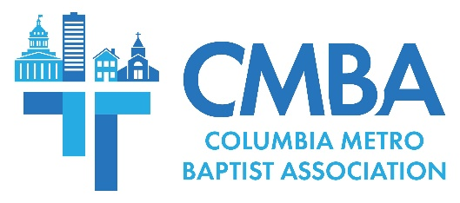

March Advisory and Executive Team Meeting Report

The CMBA Advisory Team met March 19 at GraceChurch of Columbia to conduct business and share ministry updates. At the conclusion of that meeting, Executive Team participants gathered for lunch before entering into session. Associational Missions Strategist Jamie Rogers noted the participation for both meetings was unusually high, and expressed his appreciation.

Team members heard updates from members of the CMBA Huddle who shared about recent news from among the Family of Churches, Acts 1:8 efforts to identify unreached Midlands people groups and ongoing work to create a “missions pipeline” culture, church planting, and concerns for the 11 CMBA churches that are experiencing serious needs including revitalization. CMBA WMU Director Ralphetta Davis reminded members of the WMU Spring Meeting held April 20 at Awaken Church, and gave an update on her work to grow WMU and Sisters Who Care church groups.

Director Adam Venters shared that 10 students have prayed to receive Christ through USC BCM. He gave a report from a Spring Break mission trip through Beach Reach in Panama City and expressed thanks for support from 35 CMBA churches, adding “without local churches empowering and resourcing us to do what we do, this ministry wouldn’t happen.” Venters shared a Benedict BCM update on behalf of Director Morgan Allen who reports consistent growth overall, they have seen three students pray to receive Christ, three have rededicated their lives, and Benedict BCM took 18 students to SC Baptist Convention’s Converge college retreat in February.

In his AMS report Rogers shared about the CMBA team’s recent trip to central Spain to identify potential mission projects related to the association’s five-year partnership in that area. CMBA member teams are set to begin serving in these areas in the coming year. Rogers also noted that the gospel is being shared in nine languages through weekly worship within the CMBA footprint, and that St. Andrews Baptist is now hosting three ethnic churches in its facilities on Sundays.

“This is what the body of Christ looks like,” he said, affirming St. Andrews’ openness to host the Haitian, Myanmar, and Ukrainian congregations.

Of note during the meeting was the announcement that following Denny Terrace Baptist members’ decision to officially dissolve, the church has gifted $25,000 to CMBA. Advisory Team members approved two $500 congregational grant requests, giving one grant each to the food pantries at Rosewood Community Church and Temple Zion Baptist Church. The Advisory Team also approved Rogers’ request to serve as a transitional interim pastor at Temple Baptist.

During the Executive Team Meeting, Guests Tony and Deborah Summerlin of SC Bible Reading Marathon organization presented information about the upcoming 90-hour continuous reading of the Bible from the south steps of the SC State House April 28-May 2. Volunteers are needed to read for 15-minute segments during the marathon, which happens to conclude on the National Day of Prayer on May 2. For more online information or to sign up to read, visit www.capitolbrm.org or contact the Summerlins at 919.389.5703.

Participants were reminded about two upcoming CMBA events. On April 22, guest speaker Dr. Tim McKnight will lead “The Gospel & Culture,” addressing how the gospel speaks to important current issues such as gender identity. The event is for all church membership, and will be held 6-8:30 p.m. in the North Trenholm Student Center. There is no cost to attend and the event includes supper, but participants are asked to register.

CMBA Pastors are encouraged to attend a Preaching Workshop on April 27 from 8:30 a.m. until noon at Spring Valley Baptist. Guest speaker is Dr. Robert Smith, preaching professor at Beeson Divinity School and author of “Christ Centered Preaching.” The event is free and includes a complimentary copy of Dr. Smith’s book and breakfast, but participants are asked to register.

The Advisory Team will meet again May 21 at New Heights Baptist. The next Executive Team meeting will be held September 17. At that time, Executive Team participants will vote on the 2025 CMBA budget and the moderator-elect.

