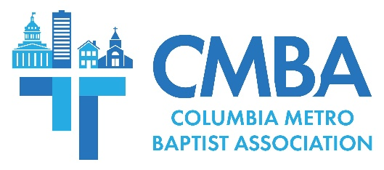

Central Spain Update from February 2024 Vision Trip

In early February, a CMBA vision team traveled to areas in Central Spain to explore more than 20 potential mission team projects linked to the association’s five-year international partnership there. The team met with International Mission Board personnel living in Central Spain who led them to visit areas where CMBA mission teams could be a part of hands-on Kingdom work. According to team member and Associational Missions Strategist Jamie Rogers, the vision trip affirmed CMBA’s commitment to reach the vast numbers of people living in the region who have never heard the gospel.

“Spain is lost. One in every 200 people you pass on the crowded streets might be a believer, which equals roughly .05% of the population,” Rogers says of the need for a gospel presence in Central Spain. “Most Spaniards aren’t even thinking about spiritual things. It is a true mission field that is far from God, but we believe God desires to bring them life. We are praying for this to happen through this partnership.”

The team took every opportunity to have gospel conversations throughout the trip, and experienced an openness from many people they encountered. In the city of Toledo, an Italian man approached one member of the CMBA team and had an extended conversation in which he asked, “what one thing would you share with me about God?” Rogers spoke with a young Muslim man who asked Rogers to “pray to the father of Jesus” about a specific request. The man agreed to remain in touch with Rogers through the online platform What’s App. Also in Toledo, the team visited a church plant, coincidentally during a youth event being held there. They met a young adult interested in missions, and the Central Spain leader remains in touch with them to give assistance.
“CMBA mission trips to Central Spain will be pure evangelistic, not like hands-on mission work in an impoverished country,” Rogers explains. “We had several really clear and pointed gospel conversations there, so expect for these trips to be centered around intentional evangelism through meeting people, having basic conversations, and then sharing the gospel if given the opportunity.”

The team visited several provincial capitals without any meaningful church presence. The Central Spain team leader says that in Segovia choirs are encouraged to sing publicly, and that black choirs have historically drawn the largest crowds. This is a great missional opportunity for CMBA churches with gifted musicians. Rogers also says Segovia is a potential location for a future CMBA church plant.

“The City of Segovia has about 55,000 people, and not one Baptist church is present. It is a beautiful, historic city that’s about an hour and a half drive from Madrid,” Rogers says. “It is a key, missional city where the gospel is virtually non-existent, and we believe it may be a place for our Family of Churches to partner together to plant a church one day.”

CMBA has two more 2024 vision trips scheduled, in May and October. The Madrid IMB team will be in Columbia Oct. 8-21, and will be joined by the Central Spain leader and his family. According to Rogers this visit will provide time for them to “work and connect with our Family of Churches,” including specific windows of time for churches to meet with them and for the missionaries to visit and share with congregations.

Prayer is a foundational element of the CMBA Central Spain partnership. CMBA encourages churches to pray for Central Spain and IMB personnel living there, pray for how their congregation can partner and support mission efforts in Central Spain, and encourage members to pray about joining an international mission team. Participating in international missions can also affect how individuals and churches view local missions.

“We believe that the European mindset is a little ahead of the culturally-Christian mindset of the average South Carolinian,” Rogers says. “By this I mean, the mindset of Europeans tends to become the mindset of Americans in our large cities, which eventually creeps into becoming the mindset of the average American. So, what we’re seeing across Europe – and in Central Spain – will ultimately help us also learn and know how to best reach Americans in coming days.”

