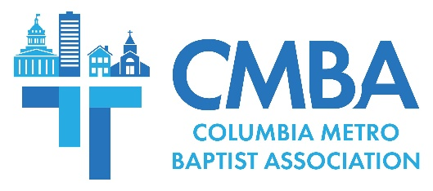

New CMBA Advisory Team Members Attend First 2024 Meeting

The CMBA Advisory Team met January 16 at New Creation Baptist to conduct business and share ministry updates. New members Joe Copeland of North Trenholm, Stephen Duke of Blaney Baptist, Jacob Helsley of First Church Columbia, and CMBA Clerk Jean Miles of Crooked Run Baptist began their service terms.

CMBA Huddle members shared reports from their areas of work, including the recent Church Equipping Workship and various communications projects. Advisory team members heard updates from CMBA churches experiencing revitalization and about 13 churches currently without a senior pastor. CMBA is assisting with pulpit supply and interim training for these congregations, in addition to having recently cohosted the first Interim Shepherd event with the SC Baptist Convention. Team members also heard about efforts to map demographics and arrange regional ministry and leadership connections, intentional missional engagements across the Midlands, and updates on ethnic church planting work.

USC BCM Director Adam Venters shared about student mission projects that happened over the holidays and about strategies to reach international students studying stateside for one semester.

CMBA WMU Director Ralphetta Davis reported from the recent national WMU meeting, where she led a breakout session. She reminded the team of CMBA’s Spring WMU meeting slated for April 20, which will be held on a Saturday in an effort to include working women. “We want all women of South Carolina to be on mission for Christ,” Davis said.

In his address to the team, Associational Missions Strategist Jamie Rogers announced three CMBA churches have pledged to increase financial giving to the association. As long-time CMBA members are aware, churches financially support the SC Baptist Convention and CMBA separately. The state convention does not transfer portions or percentages of the church gifts it receives to CMBA.

According to Rogers, church support is the “life blood” of the local association. “The only way we can do the work of coming alongside of and supporting our churches in better Great Commission fulfillment is to have financial support from our local churches. This ongoing giving is how churches are planted, congregations are strengthened, and pastors are encouraged,” Rogers explains. “We are excited about how God is building His team and allowing us to serve the needs of all of our churches. When churches give, it ensures that all of our churches receive the help they need. This is the way it’s always been in God’s Church, and it’s what we desire to carry out now as a local Baptist association on mission together.”

In other news, Rogers announced that three new church plants were begun in 2023 and that in the coming year CMBA will be incorporating new methods to better serve churches encountering challenging seasons. A group from the association will attend North American Mission Board revitalization training in February, for the second year in a row. Rogers also updated the team on “Forged Together,” a pastors’ lunch gathering held every other month to provide fellowship and time for intentional discussions, and reminded members about monthly gatherings for senior pastors’ wives.

Advisory Team members heard about several upcoming events, including the next Church Equipping Workshop held April 22 at 6 p.m. at North Trenholm Baptist, and about a leadership team traveling to Spain on January 30 to arrange details for future mission trips through CMBA’s partnership with Central Spain.

Treasurer Doug Barnett updated members on the association’s current financial status. Of note, Barnett said contributions increased during 2023 and that there was a slight return on investment assets. There were additional financial decisions made during 2023 that decreased the overall amount taken from CMBA’s savings.

In other news, team members heard a scholarship request from North Trenholm Member Kenny Robertson, who is beginning his doctoral work. The board approved his request.

2024 Advisory Team meetings will be held March 19, May 21, August 6, September 17, and November 26.

