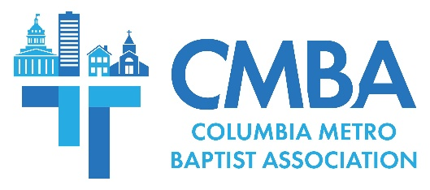

Advisory Team Affirms New Churches at End-of-Year Meeting

The CMBA Advisory Team met Nov. 28 at St. Andrews Baptist to conduct end-of-year business and share ministry updates. Of note, the team voted to affirm three new member congregations and, by so doing, agreed to establish a partnership support plan for new CMBA church plants. Associational Missions Strategist Jamie Rogers recommended that CMBA adopt a tiered approach to partner with new churches, which is in keeping with the association’s vision to “fulfill the Great Commission together” and start new congregations.

CMBA’s partnership support translates to $2,500 a year for the first three years, $1,750 in the fourth year, and $1,250 for the fifth year. Advisory team members voted to adopt this plan moving forward, and voted in affirmation to partner with and provide financial support to Elgin Community Church, New Creation Baptist, and the Chinese Church that meets at First Baptist Columbia. These churches are now participating CMBA churches through financial support of CMBA and the SC Baptist Convention.

“This is what happens when we work together and as we work together moving forward seeking to fulfill the Great Commission, I believe God will use us to do even more,” Rogers said of the association’s mission. “It is important that our existing churches seek to go after lost people, especially considering all of the new people moving into our area. Even more new church plants will be needed, also.”

Ministry reports included recent communications projects and updates on 10 CMBA churches in revitalization or different transitional processes. Central Spain missions partnership travel teams will officially begin in 2024, and an informational meeting regarding these details will be held Dec. 5 at Shandon Baptist.

Advisory team members heard about two upcoming training opportunities - on December 4 an interim pastor training event, cosponsored by CMBA and the SC Baptist Convention, will be held at the state convention building, and then on January 8 the first in a series of five topical CMBA Church Equipping Workshops will be held at Spring Valley Baptist. Church Equipping Workshops are for staff, lay leaders, and all members, and the first training will be on personal evangelism.

USC and Benedict College BCM directors shared updates from their ministries, which are supported by CMBA. Director Adam Venters estimates USC BCM’s Fall 2023 outreach opportunities have reached about 5,200 students, and the ministry has seen weekly worship attendance increase significantly. Since assuming her leadership role this fall, Benedict Director Morgan Allen says that an average of 25 students attend their weekly ministry, she has begun building relationships with about 50 students on campus, and is working to identify student leaders. Allen is also tasked with establishing a separate ministry at neighboring Allen University, which currently has no BCM ministry presence. All forms of support – including financial giving and meals for weekly gatherings – is needed for Benedict BCM ministries, and Allen can be reached at 843.731.4272.

In his address, Rogers underscored the value of CMBA’s website and social media presence which are primary forms of communications including for news, ministry stories, upcoming events and training. Rogers encouraged team members and their churches to share CMBA’s posts through social media to help more members receive this important information.

Rogers introduced “Forged Together,” new 2024 pastoral encouragement events held on the second Thursday of January, March, May, August, October, and December. Forged Together will offer opportunities for fellowship over a complimentary meal, and time for topical discussions. Each meeting will be held at North Trenholm Baptist from 11:30am-1pm.

In a final matter of business, Rogers recognized four Advisory Team members concluding their service in 2023 – Jim Ellis, Rhonda Failoni, Yvonne Murray, and Chris Seay. Members voted to affirm Primera Iglesia Bautista Pastor Cesar Velasquez as a new member and Crooked Run Baptist Member Jean Miles to serve as the 2024 CMBA Clerk.

2024 Advisory Team meetings will be held January 16, March 19, May 21, August 6, September 17, and November 26.

