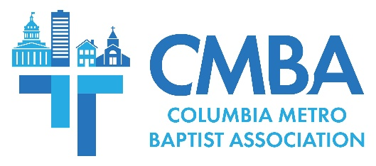

International Partnership Approved at CMBA Annual Meeting

The 2023 CMBA Annual Meeting was held Thursday, Oct. 5, at Shandon Baptist in Columbia. About 70 attendees met to conduct business and experience an evening of worship and celebration for how God is at work through the CMBA Family of Churches. Of note during the meeting, messengers voted to approve a five-year international partnership with Central Spain, in addition to the 2024 CMBA budget and bylaws revisions.

“You and I cannot lose focus for why God has us here together,” Associational Missions Strategist Jamie Rogers said. He challenged the CMBA Family of Churches to continue sharing the hope of the gospel, because “people living in the footprint of CMBA and around the world deserve our best efforts, and God deserves our best efforts.” Rogers also celebrated new church plants and ethnic congregations, revitalization updates, and shared plans for regional missions cohorts and pastors gatherings.

Moderator Freddy Johnson, pastor of North Point Community Church, led the business session which also included the election of officers. Those serving during the 2024 term are: Moderator Bill Crews, pastor of GraceChurch of Columbia; Vice Moderator Jacob Helsley, pastor of Blaney Baptist; Treasurer Doug Barnett, member of New Heights Baptist; and, WMU Director Ralphetta Davis, member of Concord Fellowship Baptist.

Greetings were brought by members of the South Carolina Baptist Convention staff and representatives from Christian Adoption Services, Circle of Welcome Ministry of the Lutheran Family Services, Connie Maxwell Children’s Ministries, Crescent Oasis Pastoral Coaching and Care, Gideons International, Heart4Schools, North Greenville University, Oliver Gospel Mission, Set Free Ministries, and Southeastern Baptist Theological Seminary.

Messengers also heard from Rev. Wes Church, pastor of First Church Columbia, who was invited to share his observations of current happenings within the Southern Baptist Convention and, specifically, from its annual meeting held this summer. He spoke to the larger denomination’s unity being “stretched at the seams,” while praising the “state of cooperation” that exists within the South Carolina Baptist Convention, the SBC’s oldest state convention. Church emphasized that SC Baptist and CMBA churches “cooperate” together and invite those that are fundamentally like-minded to financial contribute to the mission of advancing the Kingdom of God, because “the mission matters.”

Dr. Don Brock, pastor of Gateway Baptist in Irmo, was the keynote speaker, and shared a missional challenge for messengers to “love God with everything and love each other with everything, but especially love the lost.” Get your church to pray for one “lost sheep” by name, he said, “then see what God does. When you care about what God cares about – that’s when God shows up.”

-30-

