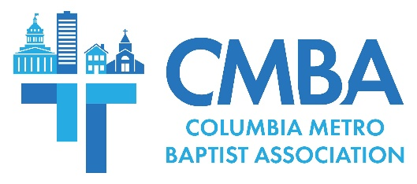

Administrative Update: Missions Partnership, ACP, Annual Meeting

A September CMBA Administrative Team meeting was held at North Trenholm to conduct business and share ministry updates. This was followed by an Executive Team session attended by representatives from CMBA churches who voted to affirm the proposed 2024 CMBA budget and bylaws revisions. Of particular interest to CMBA churches, team members were reminded of the value of church participation in the Annual Church Profile (ACP) to the association and voted to affirm the new international missions partnership location.

The South Carolina Baptist Convention’s ACP survey is now open, and CMBA churches are asked to participate in this critical data collection process. Associational Missions Strategist Jamie Rogers asks all churches to designate someone to complete their ACP response which is critical to the work of the association and the state convention. Rogers says the process also helps churches “gauge how effective they’ve been at fulfilling His mission,” and assists CMBA in knowing “how we can best come alongside of your church to provide training and encouragement in gospel-advancement endeavors.”

During the Executive Team session, the 2024 CMBA budget and bylaws revisions were presented and approved. The budget and bylaws revisions will be officially voted on by messengers to the 2023 CMBA Annual Meeting held Thursday, October 5, at 6:30 p.m. in the Shandon Baptist Church chapel, located at 5250 Forest Drive in Columbia. Following the 2023 adoption of extensive bylaws updates, the most notable revisions include the structural name change from “Administrative Team” to “Advisory Team,” and the removal of an associational annual meeting. If approved, all business and voting actions historically done during this meeting will be moved to the Executive Team meeting starting in 2024.

Rogers presented Central Spain as the recommendation from a CMBA vision team tasked with identifying an international missions partnership location for the association. Selection criteria included easy travel accessibility, regions that are home to multiple people groups, and could provide mission access to teams of all ages. If approved, CMBA’s five-year partnership with International Mission Board partners serving in Central Spain would begin in 2024.

“I desire to see Baptists involved in missions around the world, and this partnership is a way our association can connect CMBA individuals and churches looking to serve in new ways, or perhaps the first time,” Rogers says. “As we became aware of the evangelism and missions needs across Europe, I truly believe it’s the ‘forgotten mission field.’”

In other news, Administrative Team members heard reports from ongoing CMBA assistance with churches, WMU and Sisters Who Care, and updates from six church plants active across the Midlands. Morgan Allen, the new director of Benedict BCM, joined USC BCM Director Adam Venters in sharing updates from their respective campuses. As the Benedict BCM ministry enters its second full year, Allen says she is “overjoyed to be a part of what God is already doing at Benedict and Allen,” and invites CMBA churches to partner by building relationships on campus and helping to meet other needs including food for meetings.

The Administrative Team will reconvene November 28 at St. Andrews Baptist.

