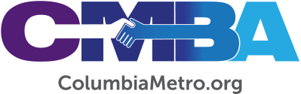

Worship, Prayer Emphasis During CMBA Annual Meeting

The CMBA Family of Churches will gather for its Annual Meeting on Thursday, Oct. 6, at 6:30 p.m. at Winnsboro First Baptist Church. This will be a time of worship, prayer, and celebration for what God is doing through CMBA churches across the Midlands. All church members and staff are invited to attend.

“We’d love to have a strong gathering of our churches for the annual meeting. We’re looking forward to seeing how God is going to use this meeting to further advance His Kingdom through our association of churches over this next year. This is a great time to come together and to hear from Him as we seek to follow Him,” says Jamie Rogers, CMBA Associational Missions Strategist.

The evening will include greetings from the South Carolina Baptist Convention, Disaster Relief, and ministry partners such as Connie Maxwell Children’s Ministries and Charleston Southern. Worship will be led by praise and worship teams from Winnsboro First Baptist and the USC Baptist Collegiate Ministry, with a message from Rev. Jarrian “JayWill” Wilson, pastor of City of Refuge Church. During the business portion of the meeting, messengers will vote on new CMBA bylaws, the 2023 budget, and hear a ministry report from Rogers.

Following the meeting, attendees are invited to stay for a time of fellowship and a reception celebrating Rogers’ appointment to CMBA.

Winnsboro First Baptist is located at 1373 Newberry Road, Winnsboro, SC 29180.

