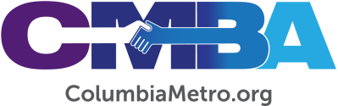

Dear CMBA Members,

I’m writing to tell you how excited I am to begin serving you all this Monday, August 22, 2022. When I was first elected as the new Executive Director of the association, my start date was originally going to be the first of September. However, since the state convention was able to find my replacement at the BCM, I’ve been able to begin a little earlier. I look forward with eager expectation to see what God will do through all of us together!
My recent times alone with God have reminded me that God is REALLY GOOD. As we all seek to be His Church here in Columbia, setting our hearts to accomplish His will for us, I’m certain that He will cause His name to be spread to the lost people in our community and to see our churches continue to exist for His glory in thriving ministries.
I’m here to serve you. I’m looking forward to getting to know all of you and to serve you in the best way possible as God leads us together. The CMBA is a great family of congregations, as I’ve already experienced, and I look forward to seeing your family grow as we set out to do as God leads. Please know that I’m praying for you and look forward to meeting you all soon!
One thing I’d like to ask you to do is to add the CMBA Annual Meeting to your calendars. It will be held on Thursday, October 6, at 6:30 p.m. at First Baptist Winnsboro. This will be a night of celebration and vision-casting, as well as my first annual meeting as your new director. Please do all you can to be there and invite your churches to attend, you will be encouraged! I look forward to seeing you all there.

For His glory,

Jamie Rogers
CMBA Executive Director

