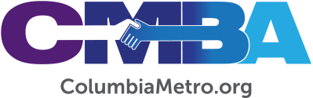

VLC Considers Additional Funding for Church Plants

The CMBA Visionary Leadership Community (VLC) met Tues., Apr. 20, at North Trenholm Baptist Church to conduct business and share ministry updates.

VLC members heard CMBA Team Huddle reports from CMBA Executive Director George Bullard, including updates on their work directly with churches. Updates on New Congregational Expressions in the association included the launch of City of Refuge congregation in April, partnership of five CMBA congregations to sponsor a new Vietnamese congregation, new Messianic Jewish congregation meeting at Spring Valley Baptist slated to launch May 15 and the relaunch of the Haitian congregation.

The VLC was introduced to New Congregational Expressions funding guidelines which address developing needs that may exceed provisions from the sponsoring congregation. The recommendation includes allowing quarterly CMBA grant amounts of up to $2,400 per year for up to seven years from the date of the first grant, requiring VLC approval on a case-by-case basis and with the expectation that these congregations eventually become a contributing CMBA member, among other administrative details. The VLC will vote in May on the adoption of these new guidelines for funding New Congregational Expressions.

In other news, VLC members approved CMBA WMU Coordinator Ralphetta Davis’ recommendation of Yvonne Murray to serve as the Multi-cultural Consultant/Sisters Who Care Consultant. Murray is a member of NorthStar Christian Center and serves as director of NorthStar’s Center of Hope. In her report, VLC Treasurer Brenda Sheets affirmed the association’s financial situation adding CMBA “continues to be a good steward of God’s money.”

VLC will reconvene May 18 at North Trenholm Baptist Church.

