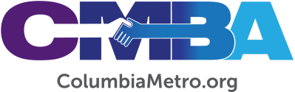

VLC Affirms Racial Reconciliation Statement, Conducts Year-End Business

CMBA’s Visionary Leadership Community (VLC) met Tuesday, Nov. 17, for its final session of the year at North Trenholm Baptist Church in Columbia to share updates and conduct business. Comprised of CMBA ministers and lay leaders, the VLC operates under the association’s vision of “starting and strengthening congregations to serve as vital and vibrant missional communities.” Executive Director George Bullard and VLC Leader Ant Frederick conducted the meeting.

Of note, the VLC affirmed the “Deep South Joint Statement on the Gospel, Racial Reconciliation, and Justice,” as reported by Baptist Press on Oct. 27. The statement was crafted by several groups of diverse pastors from Alabama and South Carolina. CMBA endorsement of the statement was on the agenda for the virtual CMBA Annual Meeting business session held Thursday, Nov. 19. The affirmation comes in addition to CMBA’s existing efforts for change that include an annual race relations conference and Martin Luther King, Jr., observance services, as well as informal racial reconciliation panel meetings and one-on-one relationship building that occurs across the association.

In its review of the annual meeting business agenda, the VLC discussed 2021 VLC member nominations and voted to recommend the following 2021 officers for election: J Thompson, moderator; Craig Bailey, vice moderator; Cookie Adams, clerk; and, Brenda Sheets, treasurer. VLC members also discussed financial reports and voted to approve adding an online CMBA giving choice for the Our One Priority Congregational Grant Fund giving option.

The VLC will reconvene Jan. 19 at North Trenholm.

