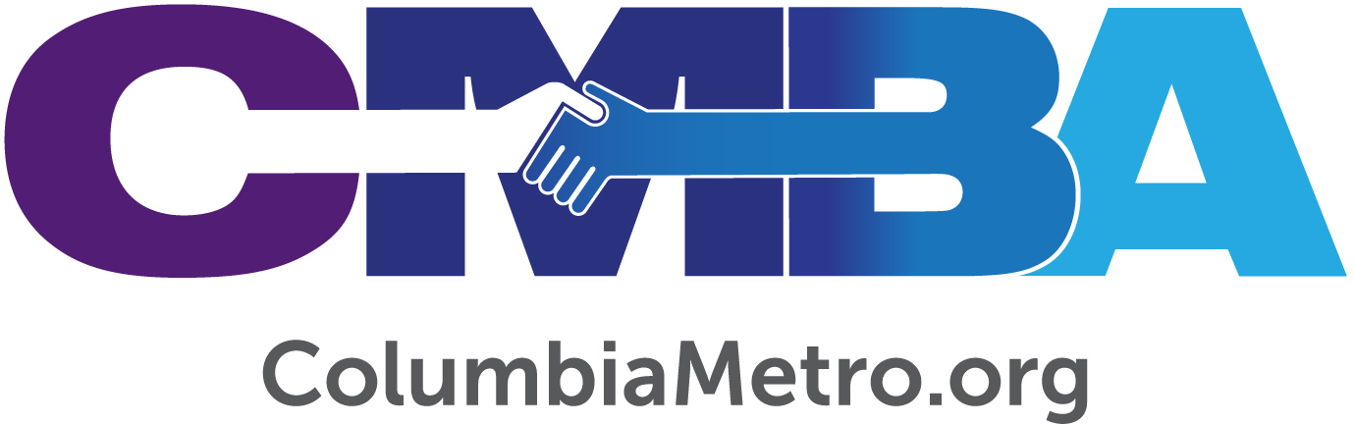

“Good Faith” and the CARES Act

Several CMBA churches have applied for funds available through the Coronavirus Aid, Relief and Economic Security (CARES) Act since it was signed into law on March 26. Relevant to churches is the Paycheck Protection Program (PPP) which, if approved, would provide a loan based on a formula tied to payroll costs for a specific indexed period and must be used for expenses through June 30. Understanding that the federal government has enacted this to promote employee retention and pay, the PPP appears to be a safe choice for churches as most of the loan would be forgiven at the end of the period providing there are careful records and expenditures are for reasons specified in the Act.

The CMBA cannot serve as legal counsel, however leaders have spent extensive time and energy researching the law, speaking with professionals and evaluating benefits and risks to churches. It is in this role that the leaders can serve as a resource to churches as each determines how to proceed. Help exists within the association, online and through community professionals.

“The Cares Act has several parts in addition to the PPP including optional expanding unemployment benefits, deferral of Social Security taxes and credit for employee retention. These can help offset some expenses if churches don’t take the paycheck protection loan. The Small Business Administration (SBA) will oversee the loan money which is designed for groups with 500 or less employees and includes churches. If at the end the church has used the funds correctly, the money will be forgiven,” says CMBA Our One Priority Mobilizer Robert Grant.

“As they approach the application process, I encourage churches to remember ethics and ‘good faith certification’ as it relates to the negative impact anticipated to the church because of the economic impacts from Covid-19,” adds CBMA Executive Director George Bullard.

Killian Baptist Pastor Chris Reinolds filed his church’s application early – a process he described as being straight forward - but shared the process can vary from bank to bank. “Be mindful that some banks may push for a traditional SBA loan, saying it’s faster and that the money can be paid back through the PPP loan. This is a risk if PPP money is not available. Banks may also encourage you to try a traditional loan to expedite the process, but you’ll be required to pay interest back on this. The banks are attempting to make the process as simple as possible though,” he says.

Bullard alerts churches that the application on the SBA website already has several editions, so “be sure you have the one with ‘nonprofit organizations’ listed at the top. Churches should go to the bank it has a relationship and existing account with, especially if churches have borrowed money through that bank.”

Harry Langley, Lite Financial accountant for CMBA, cautions churches to realize the PPP is not a “fast track” way to receive funds as there is huge interest in the program from small businesses nationwide. He also says some churches have opted not to pursue the loan to leave greater funding to small businesses.

“There is considerable discussion as to whether you can include housing allowance. Since PPP is administered via banks that have a relationship with the SBA, it depends on the bank. All of the reporting I have done has required the quarterly 941’s, which does not show housing. Each church should ask their bank if they can show on W2’s housing and whether the bank will allow it,” Langley says.

To Langley’s point, Grant cites the missions-focused nonprofit CPA and consulting services firm Capin Crouse’s definition as finding it “reasonable that ministers’ housing allowance can be interpreted as a component part of ministers salary. The minister’s housing allowance should be includable in payroll costs.” Grant says churches that use W2 forms for ministers should look at Box 14, otherwise it will possibly be overlooked as salary - Box 1 is salary, Box 14 is for housing allowance.

“The average church gives the pastor a salary, and he has to declare what portion is housing. Remember that PPP is a benefit to the church, not the minister,” he says.

Housing allowance is just one level of detail to understand when weighing the loan decision. Many churches are stalled in the application process because of governance issues related to bylaws during this time when meetings cannot be held. In response Grant has helped many churches determine what their individual bylaws state regarding voting, how they can give proper notice and discuss without an assembly.

“It’s a bylaws perfect storm – most churches were up against a wall everywhere we turned,” he says. Grant shares more business procedural assistance on the CMBA website.

CMBA has also fielded questions about the Employment Identification Number (EIN). Every church has an EIN and sometimes related ministries have one as well, such as a full-day kindergarten or counseling center. Grant reminds churches that a separate PPP application must be filed for each EIN.

“Technically a church shouldn’t have another EIN running through their books, they should be separate. The church is the employer with one EIN for church employees to be considered in its PPP calculations,” he says.

To the church still nervous to attach to a federally funded loan, Concord Fellowship Baptist Pastor Andre Rogers points to encouragement from local officials for church ministries to continue during this socially-distant but spiritually-engaged time. “I was on a call recently with Senator Tim Scott, and there is goodwill there for our churches who would struggle without assistance from our government. Some of our leaders saw fit that our churches would be included in this bill. There’s a trustworthiness we should allow and open our hearts to in this pandemic. There’s no such thing as a perfect system, stimulus or document that has everything together,” says Rogers, whose church has applied for the loan.

For his part, Grant suggests a few additional points for churches to consider. “The loan would help keep staff in place and keep missional funds flowing if the church isn’t having to spend out of reserves for personnel then they can continue to give to the association, the Cooperative Program or missional commitments. It would also help keep up with mortgage loans so a church wouldn’t have to borrow more or have a lax in payment, and it would allow ministries to reopen stronger.”

Yes, quite a few organizations are already in line to access the $350 billion allotted to keep small business (and church) staff employed. Interested churches should still apply as soon as possible, as pundits anticipate a second bailout may take place. As Grant says, “this is an unusual offer. I’m glad churches are involved in it.”

For the church not pursuing the PPP loan there are a few options to explore, including deferring on the employer’s share of Social Security taxes and employee retention credits if there is a loss of revenue (credit of percent of wages). A change in the 2020 charitable contribution amount should also be noted, indicating taxpayers will be allowed to take a $300 partial above the line contribution even for those who claim the standard deduction. There was a previous limit on itemizing charitable deductions. For 2020 there is no limit on itemizing charitable deductions and corporations are only limited to 25 percent. Grant also recommends checking out Injoy Stewardship Solutions, which offers several CARES Act resources to churches including forgivable loan calculations, payroll costs and charitable contributions.

Additional online resources:

- COVID-19 Response Resources page on www.columbiametro.org

- U.S. Small Business Administration’s COVID-19 Small Business Guidance and Loan Resources page on www.sba.gov

- For Baptists’ perspective on responses nationally and internationally:
www.namb.net
www.bpnews.net

