A Pastoral Letter from George Bullard, Executive Director to the
Columbia Metro Baptist Association Family of Congregations

Monday, March 16, 2020

I am getting continual questions and updates from our family of congregations about how to respond to the COVID-19 crisis the world is experiencing. Even within the past 24 hours I have received increased inquiries as to how to handle the current situation due to announcements make in the last 24 to 36 hours by various government officials, and in anticipation of others that may come any minute.

People are asking me for advice and counsel. At the same time, I continue to say there is no one right answer I can give them. Every situation and perspective are different. Every congregation needs to prayerfully consider what God would have them do in a proactive way at this time.

Health officials are now encouraging everyone who can to stay home. The Centers for Disease Control and Prevention is urging there be no gatherings of more than 50 people for the next eight weeks. The presidential news conference this afternoon recommended that groups of no more than 10 gather for the next 15 days. Schools have closed in our state. More closings will take place daily.

Is this too much? Is this an overkill? Is this a hoax? Is this a media creation? I believe not. I believe this is real and that we must respond. But why?

I believe the following illustration from the CDC is the main reason we must take proactive, positive action. What it illustrates is that without strong, quick action we could have more people sick than our healthcare system can handle.

We could have the situation being reported about Italy where medical personnel are having to decide who lives and who dies because they do not have the capacity of personnel, medicines, hospital beds, and medical equipment to save everyone. What a terrible thought!
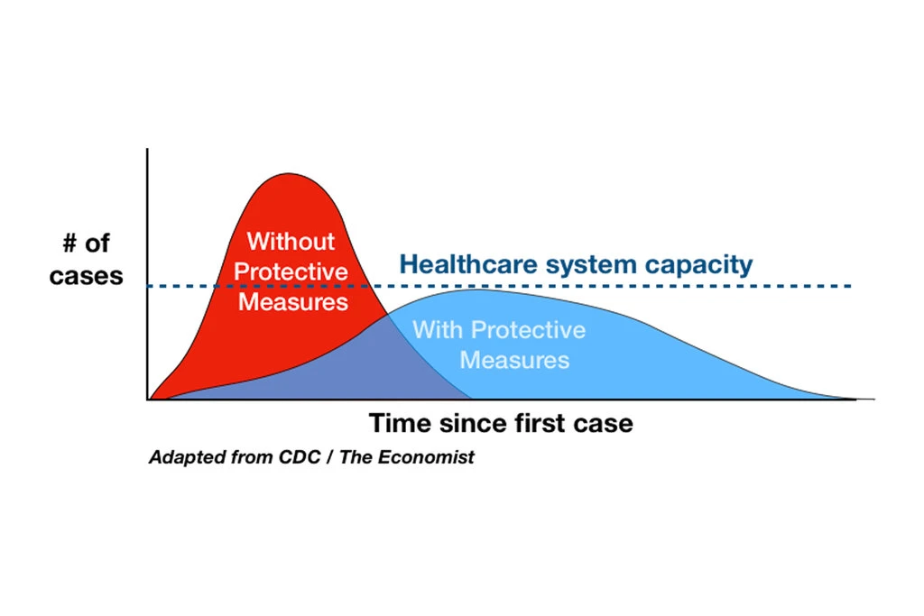

We must do our part to flatten the curve! This does not guarantee that in long-term fewer people will be infected, but it could mean in the long-term fewer people will die. If we take decisive action, and fewer people than expected get sick and die, then we have done an extremely good ministry as Christians. The people who die could be within our family and friendship circle.

What Do I Recommend?
It is a tough challenge for me to recommend anything. All congregations are autonomous. I am not your bishop. I am your servant. So, the following things are what I would seek to do if I were the pastor of one of our CMBA family of congregations.

1. I would not conduct the regular Sunday and weekly activities of the church from now through at least March 31st.

2. During that two-week period I would make plans and increase the virtual capacity of my congregation to minister to our church and community as we may face a longer period when we cannot meet for worship.

3. I would conduct all essential committee, team, and staff meetings through conference calls or web-based conferencing systems.

4. I would not conduct routine hospital and nursing home visitation, nor home visitation to families and prospects for my congregation. I would use telephone calls, written notes, e-mails, and text to communicate with them.

5. I would seek to broadcast, live-stream, or record and post to websites and social media worship services and key discipleship/small group teachings in the place of these services and events being held live, in person at our church meeting place.

6. I would proactively ask my congregation to be faithful with their tithes and offerings during any length of time we are unable to meet face-to-face in worship, and provide them with online ways to make their contributions if we do not already have that capacity.

7. I would point my church families and households to online material they can use to enhance personal and family/household worship, Bible study, and discipleship courses during this time.

8. I would ask the Sunday School classes/small groups in my congregation to set up a system and assign people to contact everyone on their role weekly to check in with them, and if doing so by voice-to-voice or face-to-face communication to pray with them about their concerns and about the COVID-19 crisis.

9. I would particularly set up a system to be sure homebound and nearly homebound people are contacted daily, and services such as shopping and delivery of supplies are offered to them.

10. I would enhance – if it is not already at this level of ministry – the prayer ministry in my church. Provide a voice mail system where people can leave prayer requests, send out a daily list of prayer request. Invite people to virtual prayer meetings online several times per week.

11. I would encourage my membership to sign up for https://blesseveryhome.com/ which is a system of knowing about your neighbors and receiving regular prompts to pray for them, and https://nextdoor.com/ which is a neighborhood-based online networking system where you can share messages with your neighbors and keep up with them.

12. I would seek to discover the ministry needs within my church family and those in our community context that are arising out of this crisis and seek ways in which we can engage in Great Commandment ministry.

13. I would make it possible for everyone who works at my church and who can to work from home rather than coming into the office daily. Let’s work remotely as much as possible.

(What would you add to this list, or modify to make it a stronger list?)

What Are Your Plans and Needs?

1. What are your plans for the next two weeks in your church?

2. What are some capacities (such as live-streaming, online giving, etc.) that you do not currently have with which you need help?

3. Do you have sources of information or assistance you want to share with other congregations in our association?

To respond, write me at GeorgeBullard@ColumbiaMetro.org or complete the survey at https://forms.gle/Xnt8Df9my7JcRynD6.

