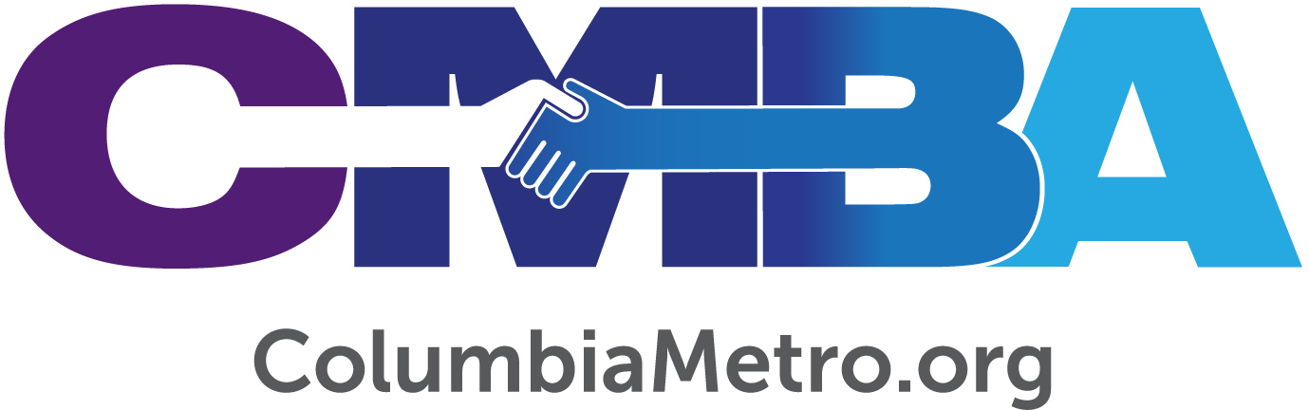

Families for All Children at the November 19th Vision Day

On November 19th Columbia Metro Baptist Association (CMBA) will conduct a Vision Day Lunch and Speaker where churches will gather to learn more about how to support efforts to provide families for all children through Foster Care. Southern Mutual Church Insurance is sponsoring the lunch, registration is free, and interested persons may register HERE. Lunch is at Noon and the program will finish by 1:30 p.m. The location is North Trenholm Baptist Church, 6515 North Trenholm Road in Columbia.

The program, “Leading Churches to Transform the Lives of Children and Families,” will be presented by Danny Nicholson, president, and others from Connie Maxwell Children’s Home (CMCH) in Greenwood. This Vision Day will introduce individuals and churches to the pilot project CMBA will support involving several churches within the association regarding foster parenting. The concept presented has implications for the full adoption process.

In partnership with Connie Maxwell Children’s Home in Greenwood, CMBA churches will discover the opportunities and established support that exist to help reach these hurting children and their families. According to Jon Jamison, Serve Team leader with the South Carolina Baptist Convention (SCBC), churches are poised to begin meeting more of these needs that exist across the state.

“Currently, there are nearly 5,000 children in the Department of Social Services system in South Carolina. While there are many foster and adoptive families serving vulnerable children, there remains a need for an additional 2,000 foster homes. With more than 2,000 churches in the SCBC family, I believe we are uniquely positioned to address this critical issue. Who better to respond to the significant needs among vulnerable children than South Carolina Baptists, who could share not only their home but the hope of the gospel as well?” asks Jamison.

Danny Nicholson and other CMCH staff who work closely with the children’s home’s foster program will share “their passion for transforming the lives of our children and families for generations.” Participants will hear an update on Connie Maxwell’s residential program, Family Care and Crisis Care, in addition to learning how Foster Care is one lens through which to see a holistic approach to ministry to children in the local church and with families in the community.
“As part of our strategic plan, Connie Maxwell will share a new collaborative framework to offer in the Columbia Metro Baptist Association whereby three to five churches would enter into a pilot project with the association and Connie Maxwell using the process of foster care to transform the lives of children,” Nicholson writes.

“As an SCBC partner, Connie Maxwell Children’s Home has a long history of caring for vulnerable children. They are most notably known for providing residential care at multiple locations across South Carolina. While they will continue in this ministry, they have made significant efforts in recent years to position themselves to also address the Foster Care ministry opportunities,” Jamison says.

Details of the pilot program are still being determined, but CMBA churches have the power to make an immediate difference in the lives of children through this ministry opportunity. As an accredited licensing agency, Connie Maxwell’s Foster Care program is ready to license, train and support foster families as it works under the calling of – “One Purpose. One Child. One Church. One Family.”

CMBA executive director, George Bullard, indicates that several CMBA churches and families are already involved in foster care. Some families are involved in the full adoption process. He said, “we look forward to sharing with our churches how they might become involved in Christ-like care ministry with several thousand children.”

“For many the pathway from the idea of fostering to becoming licensed and receiving a child placement seems unclear. What steps do I take? Who do I call? Do I need training? Our hope is to partner with Connie Maxwell to make this pathway clear for every SCBC family. Connie Maxwell will not only offer licensing they will act as your liaison with DSS and will walk with you through placement and beyond. We believe that through partnering with Connie Maxwell, we will see a movement of churches and families taking responsibility for vulnerable children in our state,” says Jamison.

Not every individual or church who attends the Vision Day presentation will be moved to become foster parents, but the information and vision that is shared for this pilot project will provide a deeper understanding of the critical family needs that exist and move participants to prayerfully consider ways to be a part of this ministry.

For more information about Foster Care through Connie Maxwell, visit www.conniemaxwell.com. To register for the Vision Day on November 19th please go HERE. To be placed on a list to receive information about this foster care pilot, send an e-mail to CMBA@ColumbiaMetro.org.

